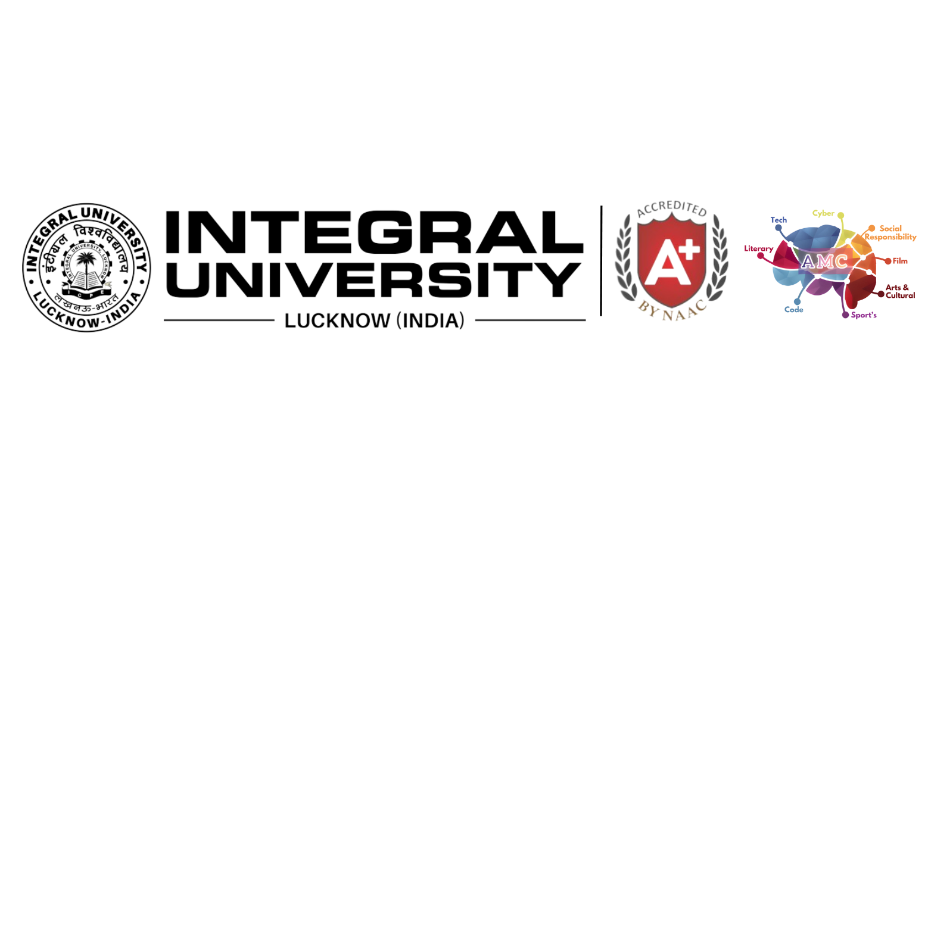

**DEPARTMENT OF COMPUTER SCIENCE & ENGINEERING**

**REPORT ON**

**CodeCraft Championship**  
*Organised by*

ACTIVE MIND CODE CLUB

**Event Overview**

The CodeCraft Championship was a thrilling coding competition designed to challenge the best programming minds across the department. This event featured six intense online rounds, where participants tackled complex algorithmic problems and coding challenges. Held from **July 21, 2024**, to **August 25, 2024** these online rounds filtered the top 15 finalists who advanced to the final offline round.

The online rounds not only tested participants' problem-solving abilities but also prepared them for the grand finale. The offline round was held on **October 07, 2024** at **Central Auditorium(Hall-2)**, where the finalists competed head-to-head for the title of CodeCraft Champion. The top 3 winner were **Farhaan Ahmad**, **Sajid Jafri** and **Sahil Verma** , who stood out for their exceptional coding skills and speed.

**Key Participants and Contributions**

The CodeCraft Championship was organized by **Code Club** in association with **Departmental Placement Committee**, with the support of key Co-Convener **Ms. Roshan Jahan** and Member **Ms. Ambreen Anees**, along with club co-ordinators **Abdul Majid, Taha Iftikhar** and **Yusuf Jamal.** Their dedication was crucial in helping the participants and smoothly managing the event

The contributions of student volunteers, led by **Tausheer Alam Shah, Yahiya Bakhtiyar and Ubaid Rehman**, were critical to the smooth execution of both the online and offline rounds. Their efforts in coordinating the rounds, managing the online platform, and providing technical support were instrumental to the event's success.

**Outcomes and Feedback**

The online rounds successfully culminated in the selection of 15 finalists from a pool of talented participants, with Farhaan Ahmad emerging as the CodeCraft Champion after the final offline round. The event was a huge success, fostering a competitive yet collaborative spirit among students. Participants appreciated the well-structured problems and the seamless flow of the event.

Feedback from participants highlighted the well-structured format of the competition and the high-quality problems. Some suggested minor improvements, such as more practice rounds and enhanced communication during the competition, which will be incorporated in future events to make them even more engaging.

We would like to extend our heartfelt thanks to all the faculty members, student volunteers, and participants who made this event a success. Special appreciation goes to the organizing team for their dedication and hard work in executing such a smooth event. Plans are already underway for next semester’s CodeCraft Championship, with more challenging rounds and broader participation to continue fostering the university’s coding community.

We would like to extend our heartfelt thanks to all the faculty members, student volunteers, and participants who made this event a success. Special appreciation goes to the organizing team for their dedication and hard work in executing such a smooth event. Plans are already underway for next semester’s CodeCraft Championship, with more challenging rounds and broader participation to continue fostering the university’s coding community.

**Top 15 Finalists**:

1. Farhaan Ahmad
2. Sajid Jafri
3. Sahil Verma
4. Akhlaque Husain
5. Arham Sheikh
6. Mushahid Khisal Ansari
7. Farhaan Khan
8. Abdullah Siddique
9. Nabeel Islam
10. Syed Mohd Faiq
11. Mohammad Roman
12. Arshad Ali
13. Akhsa Malik
14. Munaaf Nadeem
15. Mohd Ali Jasim

|  |  |
| --- | --- |
|  |  |
| Top 15 finalists. | Qualifying Rounds Glimpse |
|  |  |
| CodeCraft Final Glimpse | HOD Sir With the faculty members. |
| CodeCraft Final Glimpse | CodeCraft Final Glimpse |

**Glimpses of the event:**